

**MEMBERSHIP APPLICATION FORM 会员申请表格**

Full Name (English): __________________________________ (中): _____________________

Residential Address: ________________________________________________________________

__________________________________________________________ Postal Code ____________

Sex: *Female / Male Date of Birth: / / (dd/mm/yyyy)

NRIC No.: _______________ Nationality: __________________ Marital Status: _____________

Contact (Mobile): _________________ (Home): _________________ (O): _________________

Email Address: ____________________________________________________________________

Highest Education: ______________________________

Occupation: __________________________

Company Name: __________________________________________________________________

Year of Graduation at DHS: _______________ at level: *Sec. 4 / JC

_____________________

Signature of Applicant Date:

* Please delete accordingly

**For Official Use**

Membership Fee: **$50.00** (one-time)

Code: _______________

Receipt No.: _______________

Date: _____________________

Please complete this form and mail together with your cheque, payable to ***Dunman High School Alumni***, to the address below. Alternatively, payment could be made by PayNow to UEN S85SS0008K or QR Code below and send this form to the email address below.

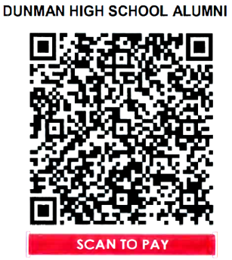

**Dunman High School Alumni**

**10 Tanjong Rhu Road, Singapore 436895**

**Tel: 3100-0809**

**Email: secretary@dunmanhighalumni.org**

**Website: www.dunmanhighalumni.org**